 Tema – Tourism + Environment Management  
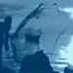
Local Knowledge – Global Reach
Arezza is a network of small town main streets and historic districts
email skype arezza1 blog g+ t in fb stu flip pint niume medium tel 240.338.6630

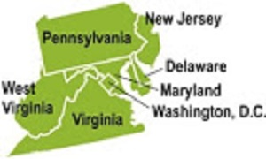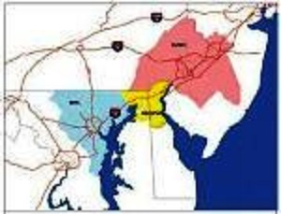

A Mid-Atlantic Cultural and Food Travel Itinerary
Philadelphia, Hershey, Harrisburg, Washington DC, Maryland and the Brandywine Valley
A seven night, eight-day program for families, schools and theme groups with a focus on:
Cultural Heritage and Local Museums give meaning and purpose to the objects on display in museums and art galleries as they disclose the historical and archaeological heritage of a community, leverage conservation and the rediscovery of cultural heritage through the arts, history, archeology, literature and architecture, preserve biodiversity and rediscover cultures associated with agricultural, coastal and river communities.
Local Food Wineries and Breweries There are several fascinating examples throughout America of a resurgence in farming that cater to an ever-increasing demand for local, quality and sustainable food, wine and ale consumption in both urban and suburban communities, fueled in part by downtown development and neighborhood construction. This, in turn, has spawned a demand for nightlife and weekend amenities for local citizens and out of town visitors. Experience uniquely local atmospheres in American communities where many historical and sustainable attractions are also present.
Preserving and Divulging the Cultural Heritage of American Communities
Communities and Local Public Transport Initiatives In recent years, efficient and affordable public transit - in the form of bus rapid transit, subways, elevated and other rail services and trolley cars – for urban, suburban and intercity service have been debated, studied and in some instances implemented. Our itineraries include major US cities with established commuter and regional service as well as communities that are implementing new transit programs. An opportunity to meet with local planners and managers and travel efficiently, safely and affordably as you visit the United States.
Water Resources Management and the Environment Visit and study the efforts of communities that are in the forefront of water resources management and other environmentally sustainable practices in coastal and river waterfront development in small towns and large cities as well as agricultural communities. Local officials and nonprofit stewards of the environment, among others, will explain their policies, programs and best management practices in wastewater and watershed management, land conservancy issues, LEED certifications, recycling, rainwater collection and energy efficient systems.
Philadelphia
history traditions and sustainability
Your visit to the US Mid-Atlantic Region begins where America began, with a two night three day stay.
Where History is Still Being Made among the many sights to take in when visiting the first capital of the United States: the Liberty Bell Center which houses the American Revolution’s defining symbol, the site of the meetings of Congress and the Constitutional Convention at the City Tavern in the Old City as well as Carpenters Hall. In Declaration House, visitors can see where Thomas Jefferson drafted the Declaration of Independence and Independence Hall where it was eventually signed.
Places to Visit a culturally rich and diverse city, Philadelphia is home to museums covering everything from natural sciences to African American history, science, archaeology and anthropology. Children will enjoy a day at the "Please Touch" Museum and the "Once upon a Nation" tour. Explore Christ Church Burial Ground; dating from 1695, the cemetery is the final resting place of Benjamin Franklin. For a sightseeing tour with a difference, take a cruise on the Delaware River. The city is also home to several wonderful gardens and arboretums. Also, the Battleship New Jersey and Valley Forge National Historic Park, site of the battle of 1777/78.
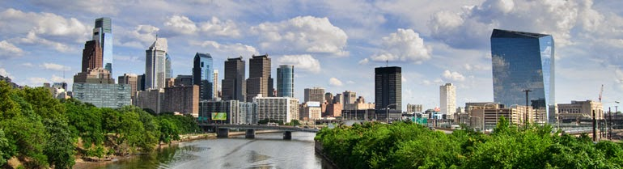
The Arts in 1805 an art collector, believing Philadelphia the best place for the encouragement of artistic taste, offered the city numerous paintings, sculptures, engravings and other art work. To accept the gift the city formed the Pennsylvania Academy of Fine Arts, the oldest art school and museum in the United States. The Philadelphia Museum of Art was founded in 1876 to maintain the art exhibits from the Centennial Exposition. It holds over 225,000 pieces of artwork including work by van Gogh, Picasso, and Marcel Duchamp. Nearby is the Rodin Museum, founded in 1929, with the largest collection of Rodin works outside of France.
Philadelphia has more public art than any other American city
The inclusion of decorative art in city structures goes back to the 19th century. In 1872, the Fairmount Park Art Association became the first private association in the United States dedicated to integrating public art and urban planning. With more murals than any other U.S. city, the Mural Arts Program has funded over 2,300 murals created by professional, staff and volunteer artists.
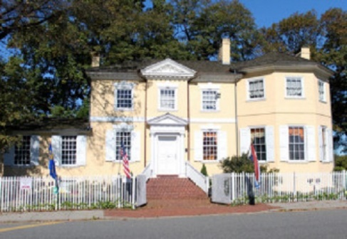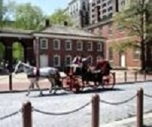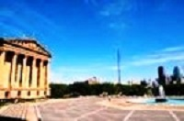
Culture Philadelphia’s history goes back to 1682 and the city’s founding by William Penn. Originally inhabited by the Lenape, Philadelphia was envisioned as a place where people could live without fear of persecution because of their religion; as a result, many came to find refuge here. As Philadelphia grew into a major political and economic center, many religious and ethnic groups have contributed to the arts, music, television, architecture and food.
Fairs & Events the Mummers Parade’s first modern version was held in 1901 on New Year’s Day. Since 1993 every summer around the 4th of July, the multi-day Welcome America event celebrates Philadelphia as the nation's birthplace. Three major annual shows in Philadelphia are the Flower Show, the Philadelphia International Auto Show and the Philadelphia Antiques Show. Festivals include the Folk Festival and Unity Day an event celebrating unity between people and families. Pride Fest events promote gay and lesbian rights. In September, the 16-day Philadelphia Live Arts Festival and Philly Fringe feature experimental art, performances and exhibits.
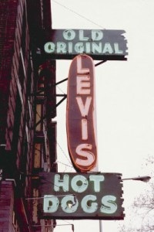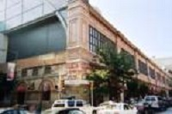
Food the city’s culinary tradition was shaped by several ethnic groups. Cheese stake and soft pretzels are well known icons of the city. The 1970s saw a restaurant renaissance that is continuing into the 21st century. Other Philadelphia food traditions include:
The hoagie a sandwich made of meat and cheese with lettuce, tomatoes, and onions
Pepper Pot, a soup of tripe, meat and vegetables dating from the Revolutionary War era
Snapper Soup a thick brown turtle soup served with sherry.
Markets towards the end of the 19th century the large number of Italian immigrants in South Philadelphia led to the creation of the Italian Market on 9th Street with numerous types of food vendors along with other shops. The Reading Terminal Market is popular with visitors.
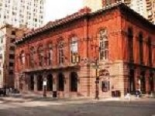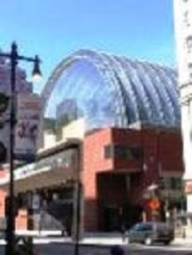
Music the city is home to a vibrant and well-documented musical heritage, stretching back to colonial times. Innovations in classical, opera, R&B, jazz and soul have earned Philadelphia national and international renown. A diverse population has also given it a reputation for styles ranging from dancehall to Irish traditional music, as well as classical and folk music. The city has played an equally prominent role in developing popular music. In the early years of rock and roll, a number of South Philadelphia-born popular vocalists made Philadelphia and popular music virtually synonymous. This led to the airing of the popular rock and roll dance show American Bandstand, from Philadelphia in front of a national audience.
The Performing Arts the city's most senior venue is the famed Academy of Music. Established in 1857, it is the longest continuously operating opera house in the United States and is home to many internationally recognized performance ensembles. The Kimmel Center for the Performing Arts, home of the internationally renowned Philadelphia Orchestra, opened in 2001. In addition, the Tower Theatre just outside of Philadelphia serves as a destination for many top touring acts.
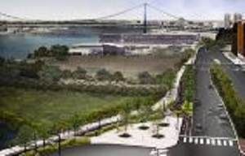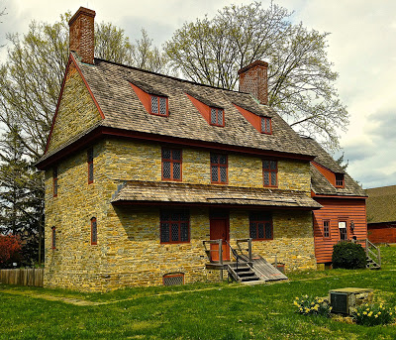
Sustainability In the city of Philadelphia, the waterfront is now a 6 mile walking and biking destination. Trail features include streetscape improvements along the entire waterfront trail, a bi-directional bikeway, pedestrian walkway and rain gardens that collect the first inch of storm water, relieving the city sewer system during major weather events, as well as benches, bike racks, decorative street pavers and innovative solar trail lighting. Center City offers a thriving culture and entertainment scene as well as contemporary arts museum with training programs and study tours for students, aspiring artists and family traveling.
Hershey Harrisburg and the Susquehanna River Valley
On Day 3 of your travel program, you transfer to the Hershey Harrisburg Region – 2 nights 3 Days.
The Susquehanna River is 464 miles (747 km) long and is the longest river on the US East Coast. With its watershed, it is the 16th-largest river in the United States, and the longest river in the continental United States without commercial boat traffic today. In the Canal Era, navigation improvements were made to enhance the river for barge shipping of bulk goods by water on the Pennsylvania Canal.
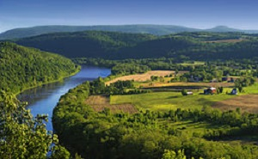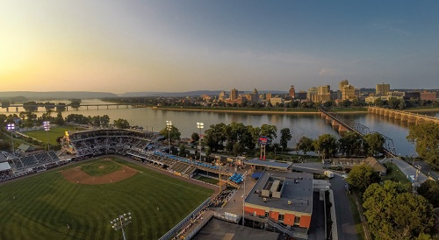
Harrisburg, the Capital of Pennsylvania, was inhabited by Native Americans as early as 3000 BC. Known as Peixtin, the area was an important trading post for Native American traders, as trails leading from the Delaware to the Ohio Rivers, and from the Potomac to the Upper Susquehanna intersected there.

Hershey is a year-round, world class travel destination with an amusement park, exclusive resorts and family attractions. In 1906, Milton Hershey opened Hershey Park as a place where his chocolate factory’s workers and their families could relax and be entertained. Surrounded by some of America’s most productive dairy farms, the world’s first modern chocolate factory and model town is a real community.

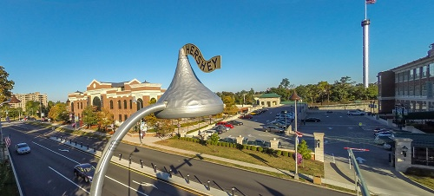
You should know that Milton Hershey purchased a ticket to travel on Titanic, but was called back to the states early for a business emergency; the famed 2200 mile Appalachian Trail curves through the Hershey Harrisburg Region for 28 miles; Hershey Gardens is 23 acres of trees, flowers and other plants;
Broad Street Market in Harrisburg is the nation’s oldest continually operating market; in Hershey, the streets are lined with Hershey’s Kisses®! Chocolate Avenue’s street lamps are shaped like the famous candies; the Rockville Bridge in Harrisburg is the longest stone masonry arch railroad bridge in the world with 48 arches measuring 70 feet each spanning the Susquehanna River.
City Island is a 63-acre tourism and recreational destination containing archeological treasures of the Susquehannocks and Iroquois tribes which established seasonal settlements here. The island was a stopping off-point for Union soldiers during the Civil War; they crossed over it by way of the Camelback Bridge to defend Harrisburg from the threat of invasion by the Confederate Army. Today, City Island is a tourist destination which is home to numerous businesses including the Harrisburg Senators Baseball Stadium, the City Islanders Soccer Stadium, the Pride of the Susquehanna, Island Breezes Gift Shop, Susquehanna Outfitters, H20 Miniature Golf, City Island Arcade/Batting Cages, City Island Railroad, and the City Island Stables.
Millersburg Borough nestled along the Susquehanna River, is quaint community radiating out from a Victorian Market Square Park featuring a Gazebo dating back to 1891. Millersburg evolved along with the introduction new forms of transportation; travel back to the 17th century and visit the Wiconisco Canal in MYO Park and a restored 1898 passenger rail station on West Center Street. The National Historic Register's Millersburg Ferry System traces its roots to 1817.

Local Culture and Heritage
The Antique Automobile Club of America Museum in Hershey, Pennsylvania opened its doors in June 2003, with over 100 cars, motorcycles plus memorabilia, collectibles, and special exhibits.
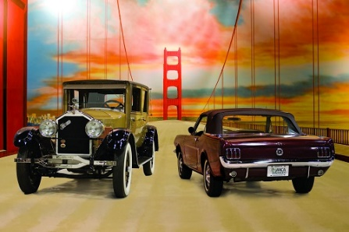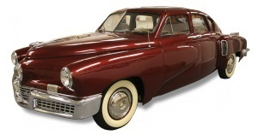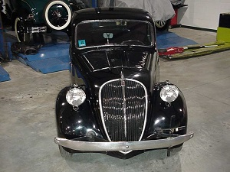
Preserving America’s Antique Automobiles
Vehicles of all types 25 years or older are welcome in the AACA. In 1993, the AACA started a nonprofit organization to further preserve these antique automobiles and educate the public.
Susquehanna Art Museum is the cultural anchor for the Central Pennsylvania community, providing innovative, relevant and engaging exhibitions and experiences for members and visitors of all ages that excite, inspire, and stimulate life-long learning.
Union Canal Tunnel Park was designated a National Historic Civil Engineering Landmark in 1970 and received its recognition as a National Landmark in 1994. Open dawn to dusk for hiking, bird watching, picnics, and recreation.
The U.S. Army Heritage and Education Center (USAHEC) is the premier facility for historical research on U.S. Army history and is dedicated to "Telling the Army story...one Soldier at a time." The expansive campus includes the Visitor and Education Center, the U.S. Army War College Library, the U.S. Army Military History Institute, and the Army Heritage Trail. Open to the public, key features of the USAHEC include interpretive and interactive exhibits, the research library and archive.
Army Heritage Trail the mile-long outdoor Army Heritage Trail allows visitors to experience history in a new way, through interactive and full-scale military exhibits. Exhibits include a Cobra helicopter, Civil War encampment cabins, WWI trench system and more highlighting the different eras of American military history. The trail is open from dawn to dusk.
The National Civil War Museum seeks to tell the whole story of this most troubled chapter in American history, focusing on the issues, the people and the lives that were affected. The causes and ramifications of this conflict that divided a Nation are investigated; both Northern and Southern viewpoints are presented; and military as well as civilian perspectives are highlighted.
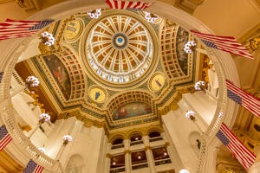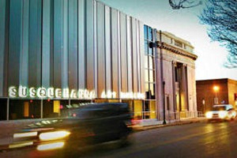
The State Museum of Pennsylvania presents the State’s heritage from the Earth's beginnings to the present. Archaeological artifacts, decorative arts, fine art galleries and industrial and technological innovations are on exhibit. The Civil War exhibit includes the 1870 painting "The Battle of Gettysburg: Pickett's Charge". Curiosity Connection is a hands-on learning environment for children. Other features: a Planetarium, Mammal Hall, Dino Lab and a restored Marshall's Creek Mastodon Skeleton.
Gettysburg Museum of the American Civil War has twelve exhibit galleries featuring artifacts, interactive displays and several films that will further immerse you in the Battle of Gettysburg and the larger context of American history and understanding its relevance in our lives today.
The Amish Village provides an authentic experience, beginning with a guided tour of an Amish farmhouse. Explore a 12-acre village, complete with a one-room schoolhouse, local crafts and treats, blacksmith barn, animals and more.
The Pennsylvania Capitol is a National Historic Landmark and Palace of Art. The dome is a 1/3 replica of Saint Peter’s Basilica in Vatican City and the grand staircase inside the main rotunda was inspired by the opera house in Paris.
Pride of the Susquehanna River Boat is one of the last remaining authentic paddle-wheel riverboats in America. Since her construction and launch in 1988, "The Pride" has carried almost a million passengers who have enjoyed themed cruises and River School Educational Trips.
Food Wine and Ale
Turkey Hill, located in nearby Lancaster County, features interactive exhibits allowing you to learn about dairy culture, how the company's ice cream and iced tea flavors are selected and created, as well as a chance to create your own virtual ice cream flavor; free tastings!
The Millworks is a local & sustainable restaurant, bar with an outdoor biergarten, art galleries with 23 artist studios, & a live music venue located in the heart of Harrisburg’s Midtown District including the Broad Street Market; Susquehanna Museum of Art; and Midtown Scholar Bookstore.
The Wineries and Breweries of the Hershey Harrisburg Region invite guests to go beyond just tasting the wines. Learn more about the process and walk away with a deeper appreciation of winemaking and Pennsylvania’s agricultural heritage. Experience the rich tastes of each winery’s blends, ciders and specialty collections. The region is also home to many small batch brewers who are following their dreams and creating trendy, welcoming spaces for beer-lovers to appreciate their favorite brews.
Washington DC and Maryland
Your next stop on this itinerary is for three nights and four days. The Washington, DC area, both in the US capital city and its suburban communities, has a unique local economy driven by government spending that has also fueled the development of downtown and neighborhood construction. This in turn has spawned a demand for nightlife and weekend amenities for both a highly educated and environmentally conscious local population and out of town visitors.
Washington, DC
historic sites museums performing arts and music
Historic sites and museums -The National Mall is a large, open park area in the center of the city. Located in the center of the Mall are the Washington Monument and the Jefferson Pier. Also located on the mall are the Lincoln Memorial, the World War II Memorial at the east end of the Reflecting Pool, the Korean War Veterans Memorial, and the Vietnam Veterans Memorial.
Located directly south of the mall, the Tidal Basin features rows of Japanese Cherry Blossoms blossom trees that were presented as gifts from the nation of Japan. The FDR Memorial and Jefferson Memorial are located around the Tidal Basin.
The Smithsonian Institution is an educational foundation chartered by Congress in 1846 that maintains most of the nation's official museums and galleries in Washington, D.C. The U.S. government partially funds the Smithsonian, thus making its collections open to the public free of charge. The most visited of the Smithsonian museums in 2007 was the Museum of Natural History located on the National Mall. Other Smithsonian Institution museums and galleries located on the mall are: the Air and Space Museum; the Museum of African art; the Museum of American History; and the Smithsonian Institution Building (also known as "The Castle"), which serves as the institution's headquarters.
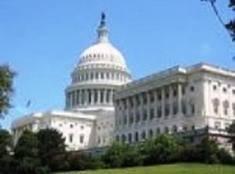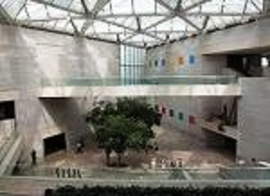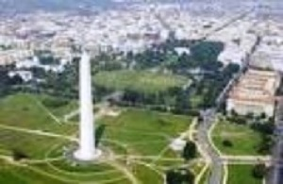
The American Art Museum (formerly known as the National Museum of American Art) is located in the same building. The Renwick Gallery is officially part of the Smithsonian American Art Museum but is located in a separate building near the White House.
The National Gallery of Art is located on the National Mall near the Capitol, but is not a part of the Smithsonian Institution. It is instead wholly owned by the U.S. government; thus admission to the gallery is free. The gallery's West Building features the nation's collection of American and European art through the 19th century. The East Building, features works of modern art.
There are many private art museums in the District of Columbia, which house major collections and exhibits open to the public such as: the National Museum of Women in the Arts; the Corcoran Gallery of Art, the largest private museum in Washington; and the Phillips Collection, the first museum of modern art in the United States. Other private museums in Washington include the Newseum, the International Spy Museum and the Naional Geographic Museum. The United States Holocaust Memorial Museum located near the National Mall maintains exhibits, documentation, and artifacts related to The Holocaust.
Performing arts and music Washington, D.C. is a national center for the arts. The John F Kennedy Center for the Performing Arts is home to the National Symphony Orchestra, the National Opera, and the Washington Ballet. Washington also has a local independent theater tradition. Institutions such as Arena Stage, and the Studio Theatre feature classic works and new American plays.
The U Street Corridor in Northwest D.C., known as "Washington's Black Broadway", is home to institutions like Bohemian Caverns and the Lincoln Theatre. Other jazz venues feature modern blues such as Madam's Organ in Adams Morgan and Blues Alley in Georgetown. D.C.
Silver Spring, Maryland
Located in Montgomery County, one of the most affluent and educated communities in the United States and strategically located to visit the nearby capital of the United States, Annapolis, Chesapeake Bay and the Eastern Shore of Maryland, Baltimore, Philadelphia and New York City, the area is home to many talented people that work in business, government and the nonprofit sectors.
Arts and Entertainment Silver Spring hosts several entertainment, musical, and ethnic events throughout the year such as the AFI Docs film festival hosted by Discovery and the American Film Institute, the Annual Thanksgiving Day Parade for Montgomery County and the Silver Spring Jazz Festival.
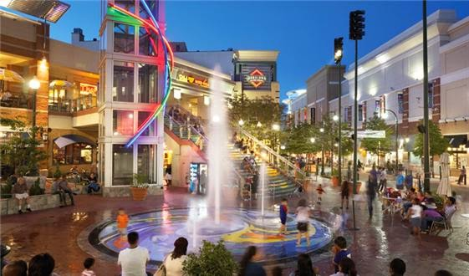
As a richly different ethnic community, dining in Silver Spring is also extremely varied with American, African, Burmese, Ethiopian, Moroccan, Italian, Mexican, Salvadoran, Jamaican, Vietnamese, Lebanese, and fusion restaurants, as well as many national and regional chains. There are also numerous examples of public art as well as shopping opportunities at farmers and other traditional markets.
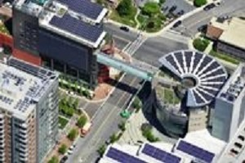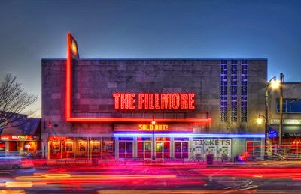
Innovation This community is in the forefront of innovative practices. With an increasingly diverse and environmentally conscious population in the downtown area, and its traditional role as a commuter and regional transportation hub, Silver Spring is an innovator in energy efficiency, watershed management, education and training services, place making as well as numerous transit initiatives. The downtown transit center will feature the new Purple Line, including a stop at the start of the art public library, Walking and biking trails offer visitors and commuters alternative means to connect with other communities in the region.
Potomac River Trails
The Lower Potomac, Anacostia, Patuxent and Wicomico rivers are among the major waterways in the region, but hundreds of smaller streams, creeks and rivers abound providing numerous opportunities for recreational boating.
Anacostia River Watershed 176 square mile area of land encompasses most of the eastern half of the District of Columbia and large portions of Prince George’s County and Montgomery County in Maryland. The Anacostia has 13 major tributary creeks and streams - many with their own sub-watershed citizen advocacy groups; it starts near Bladensburg, MD, and runs for 8.5 miles before meeting the Potomac River at Hains Point in Washington, DC.

Anacostia River Trails and Port Towns The word Anacostia is derived from the Nacotchtank Indian word anaquash; it means village trading center. In the 18th century the port at Bladensburg, Maryland, was 40 feet deep and served as a major center for colonial shipping fleets. Today, at Bladensburg Waterfront Park, site of the old port, the water often measures 3 feet deep or less. In the 18th century, the Anacostia River flowed through 2,500 acres of tidal wetlands. Today, less than 150 acres of wetland remain.
Wildlife the Anacostia River supports 188 species of birds and nearly 50 species of fish. Some of the animals you can see in and along the river include: bald eagles, beavers, white perch, ospreys, striped bass, cormorants, crayfish, herons, turtles, egrets, otters, herring, red fox, shad, kingfishers, and bullhead catfish.
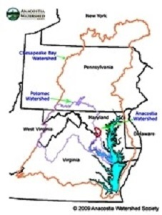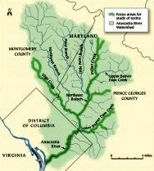
Pollution and its Effect of Fish Species Each year, Washington's antiquated combined sewer system dumps over 2 billion gallons of raw sewage and storm water directly into the river. Recent efforts have begun to reduce this overflow volume. According to the National Oceanic and Atmospheric Administration (NOAA), more than 20,000 tons of trash and debris enter the Anacostia's waters each year. Between 1989 and 2009, AWS volunteers collected and removed more than 850 tons of trash from the watershed. Experts estimate that approximately two-thirds (2⁄3) of brown bullhead catfish in the Anacostia River have tumors. The bullhead is an environmental indicator species for the Anacostia.
Annapolis, Maryland
Hammond-Harwood House an 18th Century Arts & Architecture Museum in Annapolis, Maryland
The gentleman planter Matthias Hammond began work in 1774 with renowned architect William Buckland on plans for a new, elegant townhouse in the most fashionable area of Annapolis.
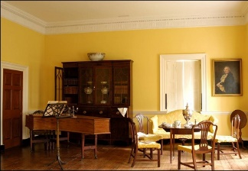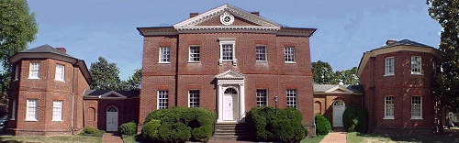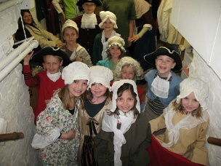
An Anglo-Palladian mansion featuring some of the best woodcarving and plasterwork in America
Reading and Writing History Designed to give high school students a hands-on lesson about Colonial American history. The program is divided up into three mini-sessions each with its own goals: a colonial house tour, an introduction to history resources, and a session of hands-on group study. The program covers topics which include common and indentured laborers, slave life, the life of craftsmen, gentry activities and leisure time, decorative arts, and architecture. Other topics may be added on request.
Baltimore, Maryland
Historic Ships in Baltimore’s half-day programs provide an immersive hands-on historic experience with a twenty-first century applicability that encourages team-work, problem solving, and learning. Each program provides introductory ship tours, after which students focus on two of six particular areas of the ship and begin to develop a more specialized vocabulary and skill set. At the end of their 2 ½-hour program, learning is reinforced in a written exercise and assessment. Assessment results are forwarded to the teacher. Each program provides a uniquely different approach toward reading, listening, development and reinforcement, involve hands-on activities and are fun, including a live-firing of one of the USS Constellation’s cannons.
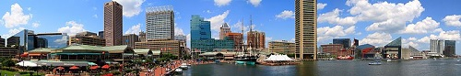
The Brandywine Valley
On Day 8, your travel program concludes with a visit to the Brandywine Valley.
Development & Conservancy Issues In the 1960s, Chadds Ford, Pennsylvania in the historic Brandywine Valley, faced a possible massive industrial development that would impact a largely rural community. Also, development plans in floodplain areas threatened to devastate water supplies for numerous communities in southeastern Pennsylvania and northern Delaware.
A group of local residents bought endangered land and founded the Brandywine Conservancy in 1967. The first conservation easements, protecting more than five and one-half miles along the Brandywine, were granted in 1969.
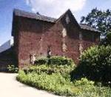
These Experiences have placed the Brandywine Valley communities in the forefront of responsible land use, open space preservation and water protection with a focus on integrating conservation with economic development through land stewardship and local government assistance programs working with individuals, state, county and municipal governments and private organizations to permanently protect and conserve natural, cultural and scenic resources.
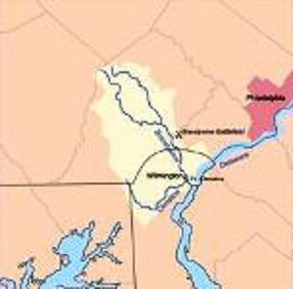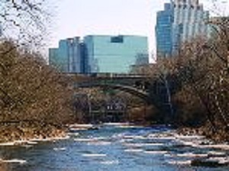
In 1971, the Conservancy opened a museum in the renovated Hoffman’s Mill, a former gristmill built in 1864, part of the Conservancy’s first preservation efforts. It contains an unparalleled collection of American art with emphasis on the art of the Brandywine region, illustration, still life and landscape painting, and the work of the Wyeth family.

John Leboffe
Tema - Tourism and Environment Management
8403 Colesville Road – suite 1100
Silver Spring, MD. 20910
https://arezzanetwork.blogspot.com
tema@arezza.net tel 240.338.6630 skype arezza1

